**Document 1**

**Organizing the project structure**

**Cloning the repo**

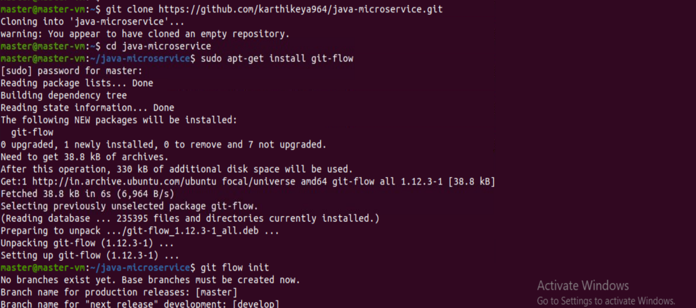

Pushing to our github repo

Installing maven

Github webhook:

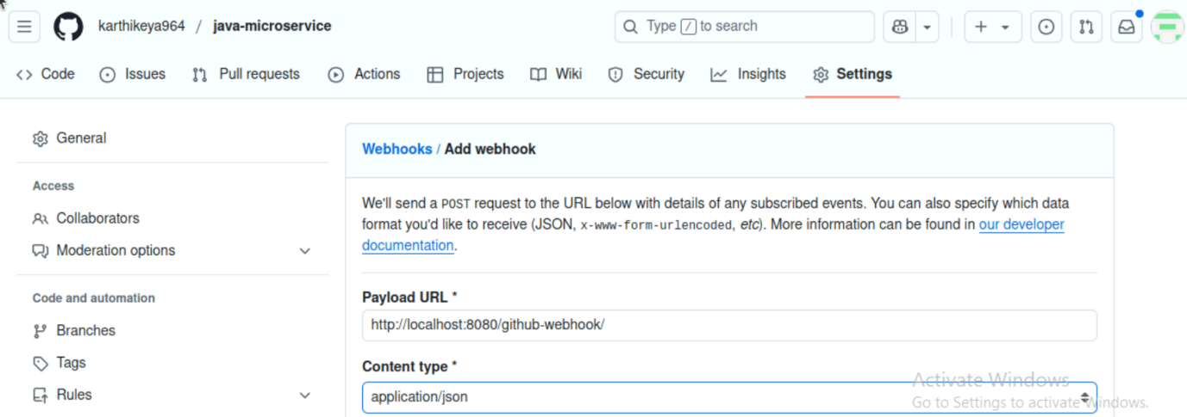

Docker file:-

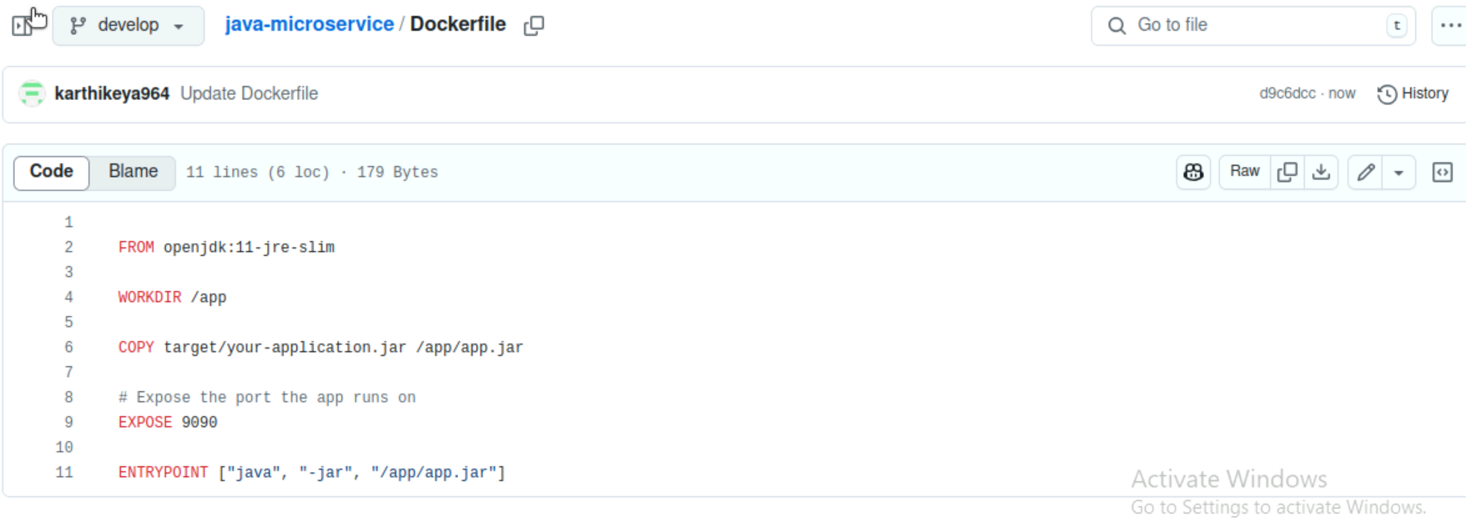

Docker: Building the docker image and pushing it to docker-hub

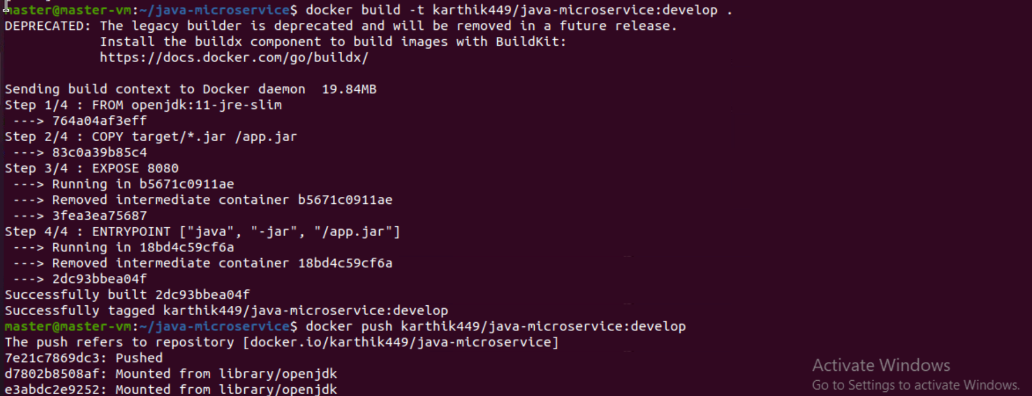

Docker image pushed in dockerhub

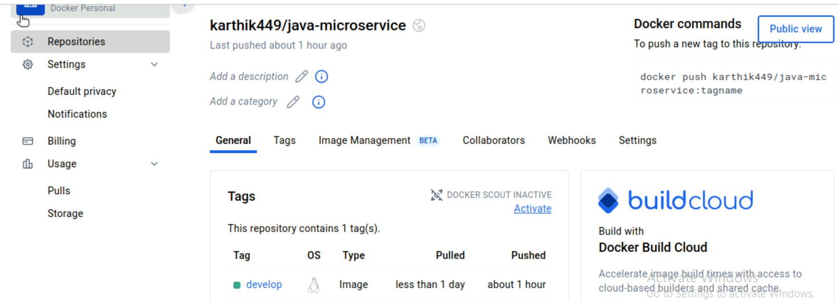

**Kubernetes**

Deployment.yaml file

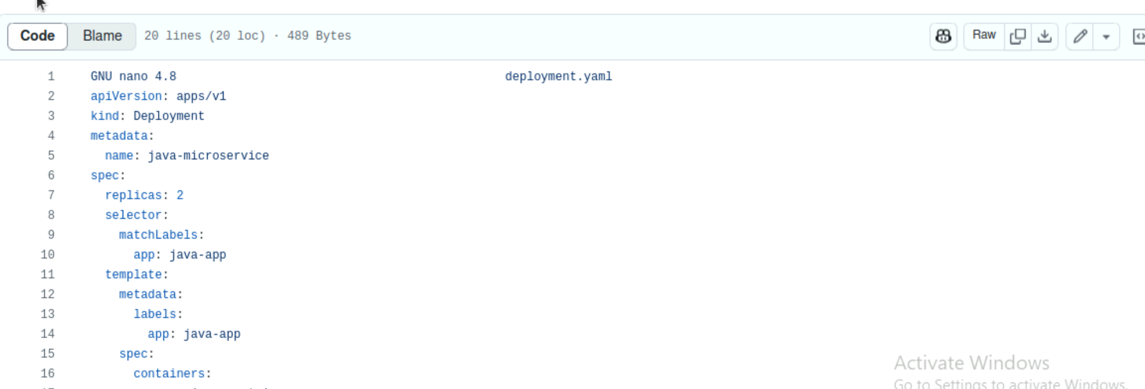

**Service.yaml file**

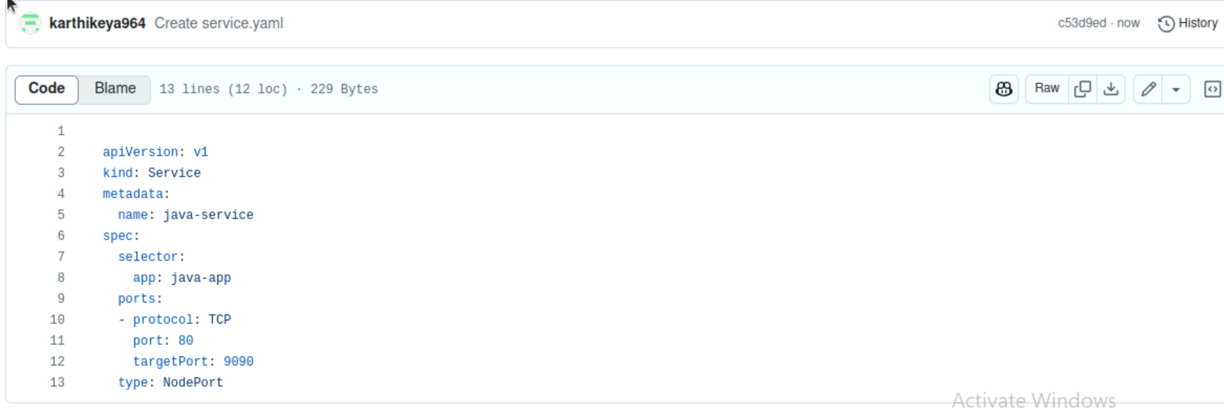

**Pods are running**



**Verifying the deployments and services**

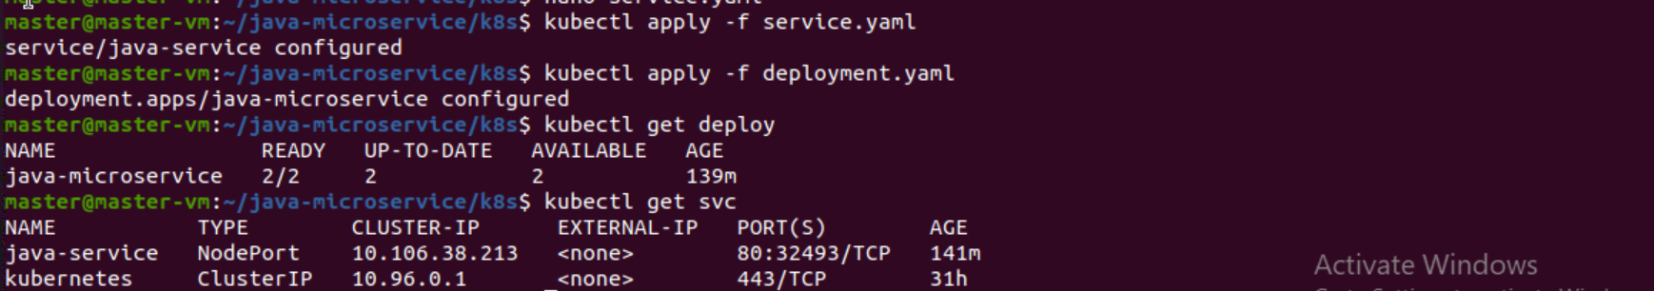

**Pom.xml file:-**

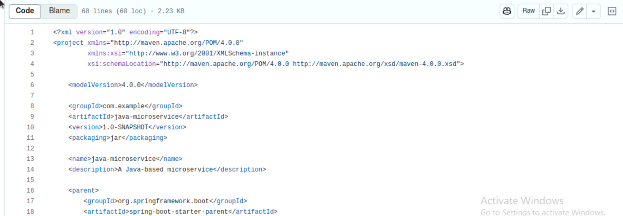

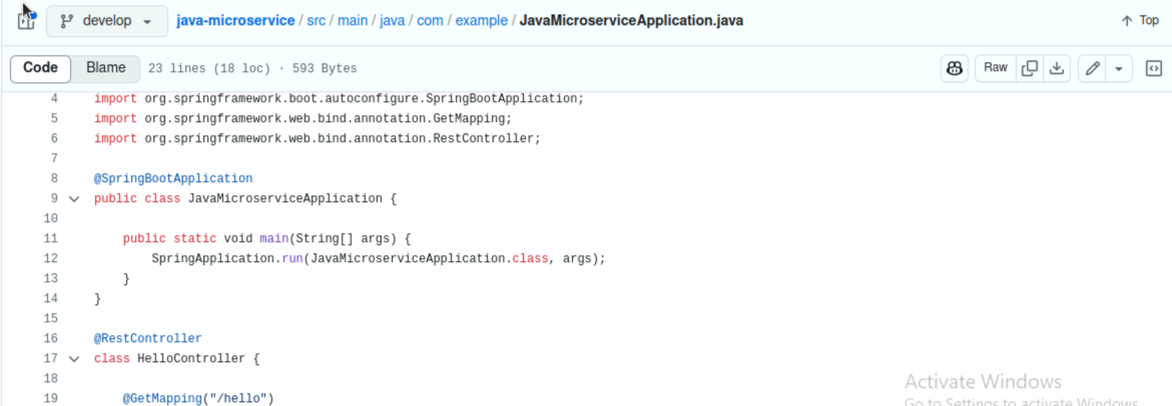

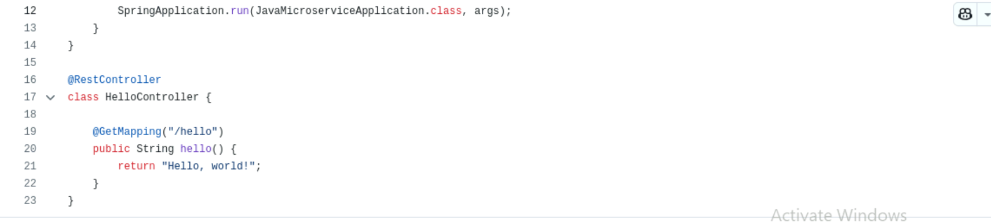

**Jenkins file:**

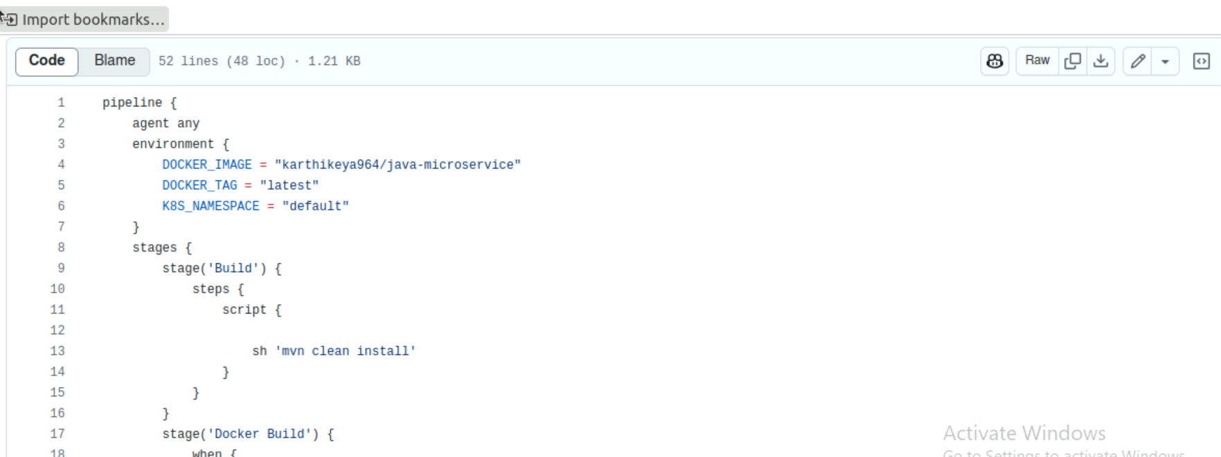

**Jenkins build:**

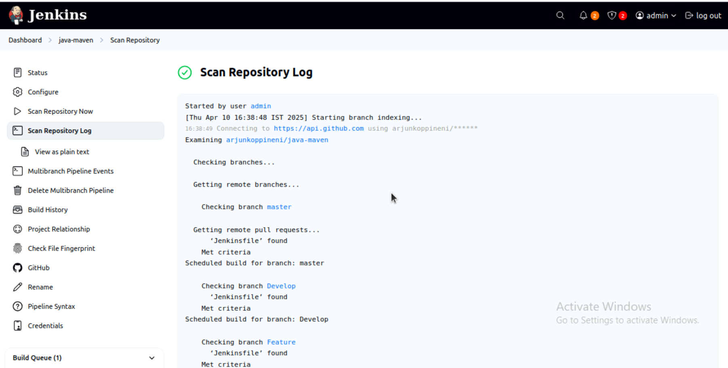

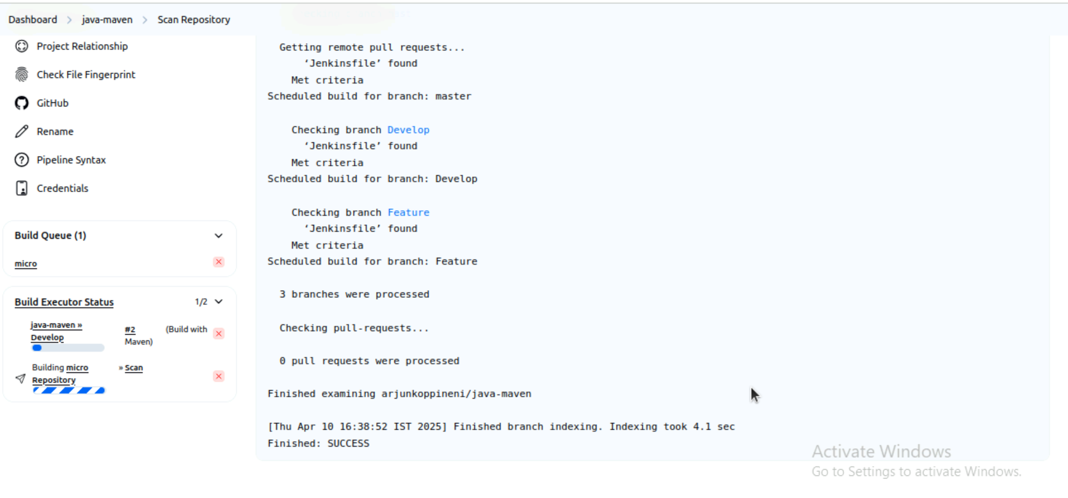

Ouput:

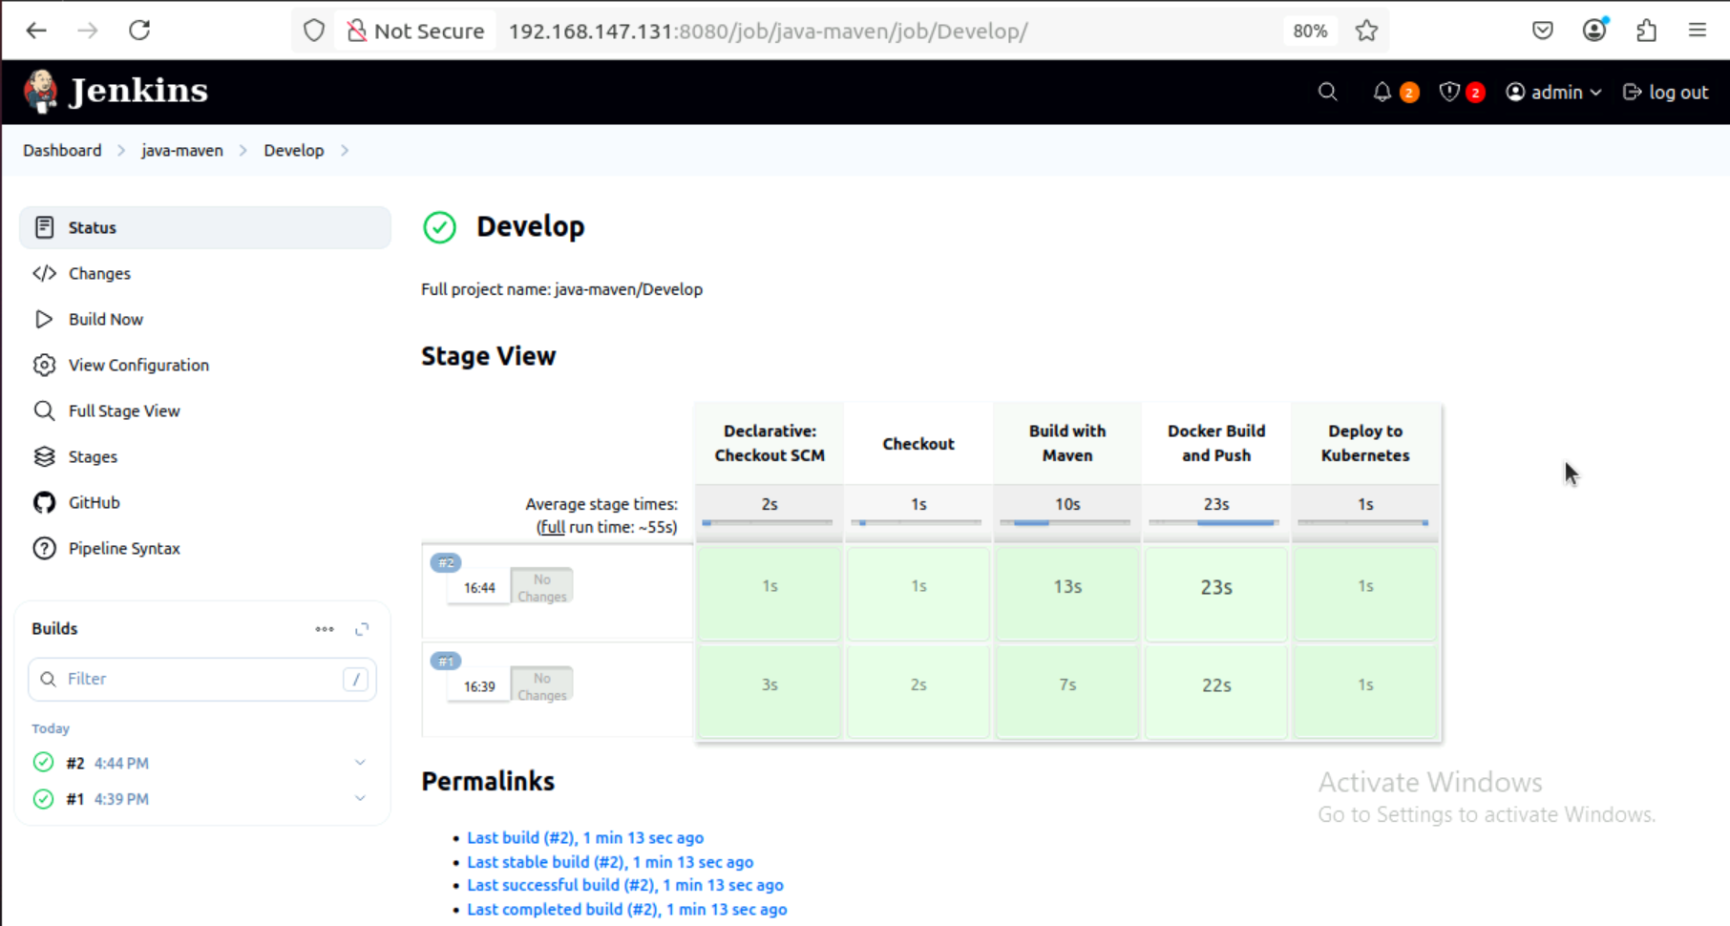

**Github structure**

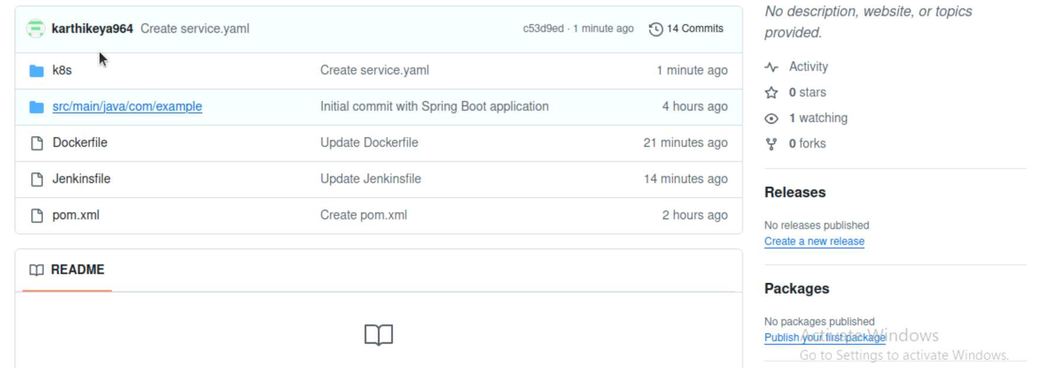

**Github repo link:**<https://github.com/karthikeya964/java-microservice.git>